**Traffic Light Control System**

*Project Synopsis Submitted*

*to*

**MANIPAL ACADEMY OF HIGHER EDUCATION**

*For Partial Fulfillment of the Requirement for the*

*Award of the Degree*

*Of*

**Bachelor of Technology**

*in*

**Information Technology**

*by*

**Roshan Kumar (220911016)**

**Shragvi Raviraj(220911037)**

**Medini Rao(220911038)**

*Under the guidance of*

Dr. Rashmi Naveen Raj

Associate Professor

Department of I&CT Department of I&CT

Manipal Institute of Technology Manipal Institute of Technology

Manipal, Karnataka, India Manipal, Karnataka, India

**INDEX**

| **S.No** | **Title** | **Page No** |
| --- | --- | --- |
| 1 | Introduction | 2 |
| 2 | Literature Review and Components Required | 3 |
| 3 | Methodology and Results and Discussions | 4 |
| 4 | Pin Diagram and Block Diagram | 4 |
| 5 | Code | 6-11 |
| 6 | Application | 12 |
| 7 | References | 13 |

**Introduction**

Urban transportation is a cornerstone of modern society, yet managing traffic flow at intersections often poses significant challenges. Conventional traffic signal systems frequently struggle to adapt to fluctuating traffic conditions, resulting in congestion and frustrating delays for commuters. In response to this pressing issue, our project introduces a groundbreaking solution: a density-based traffic light control system designed to revolutionize intersection management.

Equipped with sensors placed strategically on each of the four roads, our system leverages the LPC1768 microcontroller, programmed in embedded C, to gather real-time data from IR sensors. Through sophisticated analysis of vehicle density on each road, the microcontroller identifies the road experiencing the highest traffic volume. This critical insight enables dynamic adjustments to traffic signal timings, ensuring that green light allocations prioritize the busiest road at any given moment.

The project methodology encompasses sensor integration, algorithm development, and signal control implementation. By strategically placing IR sensors and employing advanced algorithms, our system accurately assesses vehicle density to determine the optimal allocation of green light time. The ultimate goal? To streamline traffic flow, reduce congestion, and enhance intersection efficiency by prioritizing the road with the greatest vehicle presence.

Through innovative technology and meticulous implementation, our density-based traffic light control system represents a significant step forward in urban traffic management. By focusing on real-time data analysis and adaptive signal control, we aim to alleviate congestion and improve the commuting experience for all.

**Literature Review**

**Automated Adaptive IR based Traffic Control**

The proposed model for adaptive traffic control integrates real-time traffic density monitoring, enhancing system efficiency. It employs a hybrid approach combining sensor networks and RFID technology to prioritize emergency vehicles. Flow chart 1.1 below illustrates the process, detailing how data from sensors and RFID technology are utilized to adjust traffic control measures.

Infrared sensors are placed at regular intervals along each lane which detect objects and output a binary signal based on their presence. By analysing the output using a counter index formula Index [ i ] = Output [ i + 1 ] AND Output [ i ]. the traffic mode is determined, ranging from Extremely High to Low traffic. The table provided (Table 1.1) outlines the IR sensor outputs and their corresponding traffic modes. The absence of a signal at specific sensors indicates varying levels of traffic density, with zero outputs at different sensors corresponding to different traffic conditions. This method allows for real-time monitoring and classification of traffic density based on the data collected by the sensors.

The system ensures efficient traffic flow by adjusting signal timings based on traffic density and detecting emergency vehicles without human intervention. The model's flexibility in adjusting green path timings based on traffic volume and the prioritization of emergency vehicles enhances overall system efficiency

**Traffic Control System for Emergency Vehicles using RFID and Sensors**

The system aims to control traffic lights for emergency vehicles using RFID and ultrasonic sensors. Traffic lights play a crucial role in managing vehicle flow, especially during emergencies. The system ensures that emergency vehicles clear junctions without delays at traffic signals. Operating autonomously, it guarantees a clear path for emergency vehicles, reducing traffic congestion, aiding in timely arrivals, and minimizing accidents.

**Components Required**

Hardware

ALS-SDA-ARMCTXM3-01

10 core FRC cables

USB to B type cable

8 IR Sensors

4 Traffic Light Module

Jumper Wires

Software

KEIL

Flash Magic

**Methodology**

1. Connect the ARM Cortex-M3 board to a PC and power supply.

2. Connect the 8 IR sensors to the board using Female-to-Female jumper wires. The Ground and VCC of all the IR sensors are shorted together using a Perf board as the kit lacked the number of ground and vcc pins.The output of the IR sensor was connected to connected B,pins P1.23 - P1.24 for road A.P1.25 -P1.26 for road B, P2.10-P2.11 for road C,P2.12-P2.13 for road D.

3. LED modules are connected to connected A such that road A has green on pin P0.4, yellow P0.5 and Red P0.6 and P0.7-P0.9 for green yellow and red respectively with respect to road B, pins P0.15-P0.17 for road C and pins P0.18-P0.20 for road D.

4.The IR sensors then detect the density of the vehicles on the road and allow vehicles to pass based on the following code.

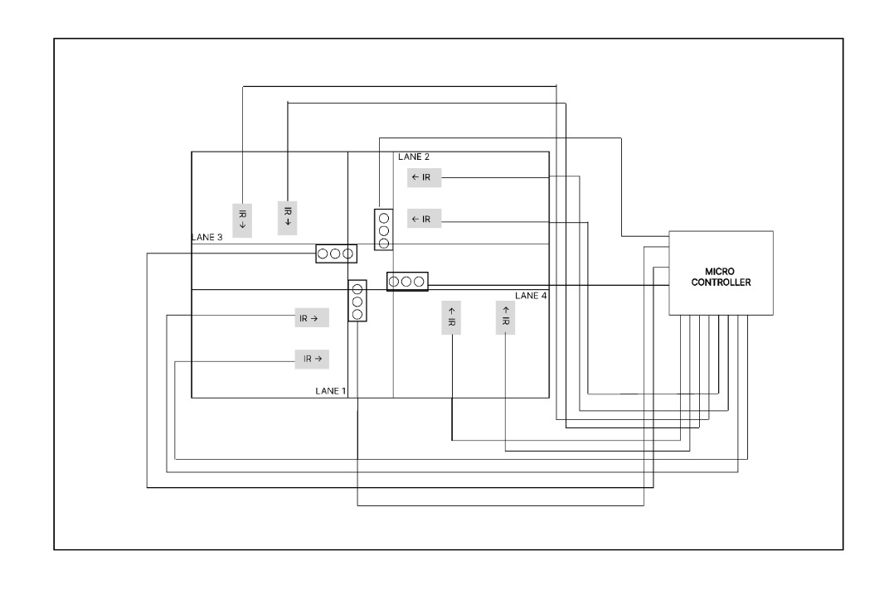

**Pin Diagram**

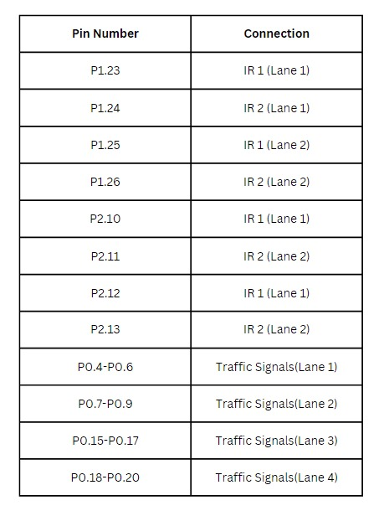

**Code**

#include<LPC17xx.h>

int irIP, lane1, lane2, lane3, lane4;

int red=4, yellow=2, green=1;

int light1, light2, light3, light4;

void readlane1()

{

lane1 = (LPC_GPIO1->FIOPIN >> 23) & 0x3;

}

void readlane2()

{

lane2 = (LPC_GPIO1->FIOPIN >> 25) & 0x3;

}

void readlane3()

{

lane3 = (LPC_GPIO2->FIOPIN >> 10) & 0x3;

}

void readlane4()

{

lane4 = (LPC_GPIO2->FIOPIN >> 12) & 0x3;

}

void setlight(int lane, int light)

{

switch (lane)

{

case 1:

LPC_GPIO0->FIOSET = 0 << 4 | 0 << 5 | 0 << 6;

LPC_GPIO0->FIOSET = light << 4;

light1 = light;

break;

case 2:

LPC_GPIO0->FIOSET = 0 << 7 | 0 << 8 | 0 << 9;

LPC_GPIO0->FIOSET = light << 7;

light2 = light;

break;

case 3:

LPC_GPIO0->FIOSET = 0 << 15 | 0 << 16 | 0 << 17;

LPC_GPIO0->FIOSET = light << 15;

light3 = light;

break;

case 4:

LPC_GPIO0->FIOSET = 0 << 18 | 0 << 19 | 0 << 20;

LPC_GPIO0->FIOSET = light << 18;

light4 = light;

break;

}

}

void readlanes()

{

irIP = ((LPC_GPIO1->FIOPIN >> 23) & 0XF) | ((LPC_GPIO2->FIOPIN >> 6) & 0XF0);

lane1 = irIP & 0x3;

lane2 = (irIP >> 2) & 0x3;

lane3 = (irIP >> 4) & 0x3;

lane4 = (irIP >> 6) & 0x3;

}

int main()

{

SystemInit();

SystemCoreClockUpdate();

LPC_PINCON->PINSEL3 = 0; //P1.23 - P1.26 SENSOR I/P GPIO

LPC_PINCON->PINSEL4 = 0; //P2.10 - P2.13 SENSOR I/P GPIO

LPC_PINCON->PINSEL0 = 0; //P0.4 - P0.9, P0.15 LED O/P GPIO

LPC_PINCON->PINSEL1 = 0; //P0.16-P0.20 LED O/P GPIO

LPC_GPIO1->FIODIR = 0; //P1.23 - P1.26 I/P SENSOR

LPC_GPIO2->FIODIR = 0; //P2.10 - P2.13 I/P SENSOR

LPC_GPIO0->FIODIR = 0X3F << 4 | 0X1F8 << 15; // P0.4 - P0.9, P0.15-P0.20 O/P LED

while (1)

{

readlane1();

readlane2();

readlane3();

readlane4();

if (lane1 == 3 || lane2 == 3)

{ // If lane 1 or lane 2 has high traffic

// Set lane 3 and lane 4 to red, lane 1 and lane 2 to green

if (light3 == green && light4 == green)

{

setlight(3, yellow);

setlight(4, yellow);

//delay

}

setlight(3, red);

setlight(4, red);

setlight(1, green);

setlight(2, green);

//delay

}

else if (lane3 == 3 || lane4 == 3)

{ // If lane 3 or lane 4 has high traffic

// Set lane 1 and lane 2 to red, lane 3 and lane 4 to green

if (light1 == green && light2 == green)

{

setlight(1, yellow);

setlight(2, yellow);

//delay

}

setlight(1, red);

setlight(2, red);

setlight(3, green);

setlight(4, green);

//delay

}

else if (lane1 == 1 || lane2 == 1)

{ // If lane 1 or lane 2 has low traffic

// Set lane 3 and lane 4 to red, lane 1 and lane 2 to green

if (light3 == green && light4 == green)

{

setlight(3, yellow);

setlight(4, yellow);

//delay

}

if (light3 == yellow && light4 == yellow)

{

setlight(3, red);

setlight(4, red);

}

setlight(1, green);

setlight(2, green);

//delay

}

else if (lane3 == 1 || lane4 == 1)

{ // If lane 3 or lane 4 has low traffic

// Set lane 1 and lane 2 to red, lane 3 and lane 4 to green

if (light1 == green && light2 == green)

{

setlight(1, yellow);

setlight(2, yellow);

//delay

}

if (light1 == yellow && light2 == yellow)

{

setlight(2, red);

setlight(1, red);

}

setlight(3, green);

setlight(4, green);

//delay

}

}

}

**Results and Discussion**

1.The Traffic Control System Initially gave false output using timers and hence timers were replaced with delays to overcome the problem.

2.The Round Robin Technique was enforced when the density across all roads was the same.

3.When density across one road was high ,the other roads’ led modules had their inputs going to the red led.

4.This system can also be implemented in real life scenarios after improvisation.

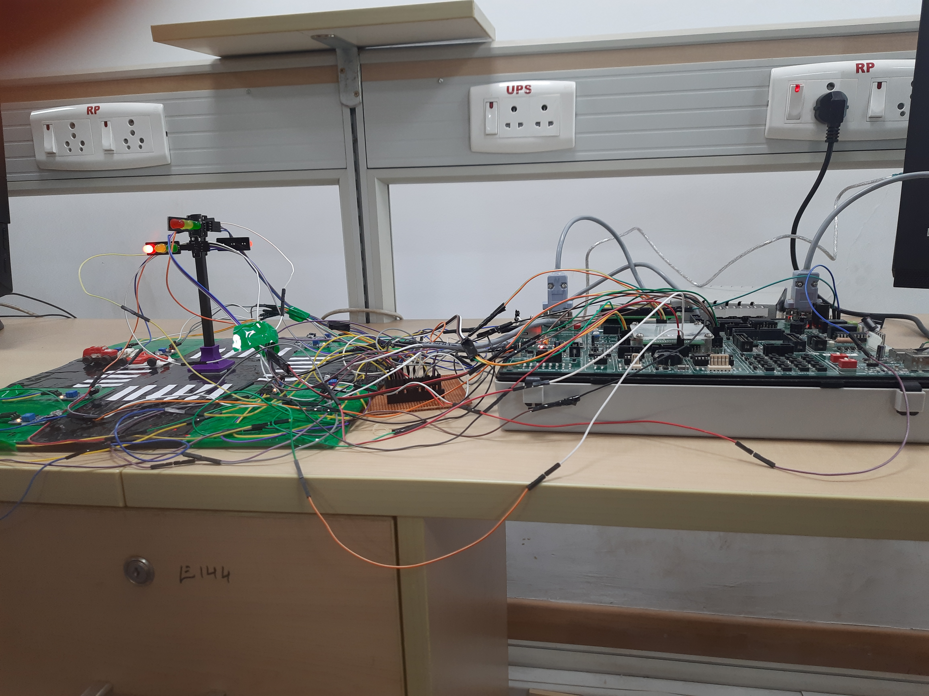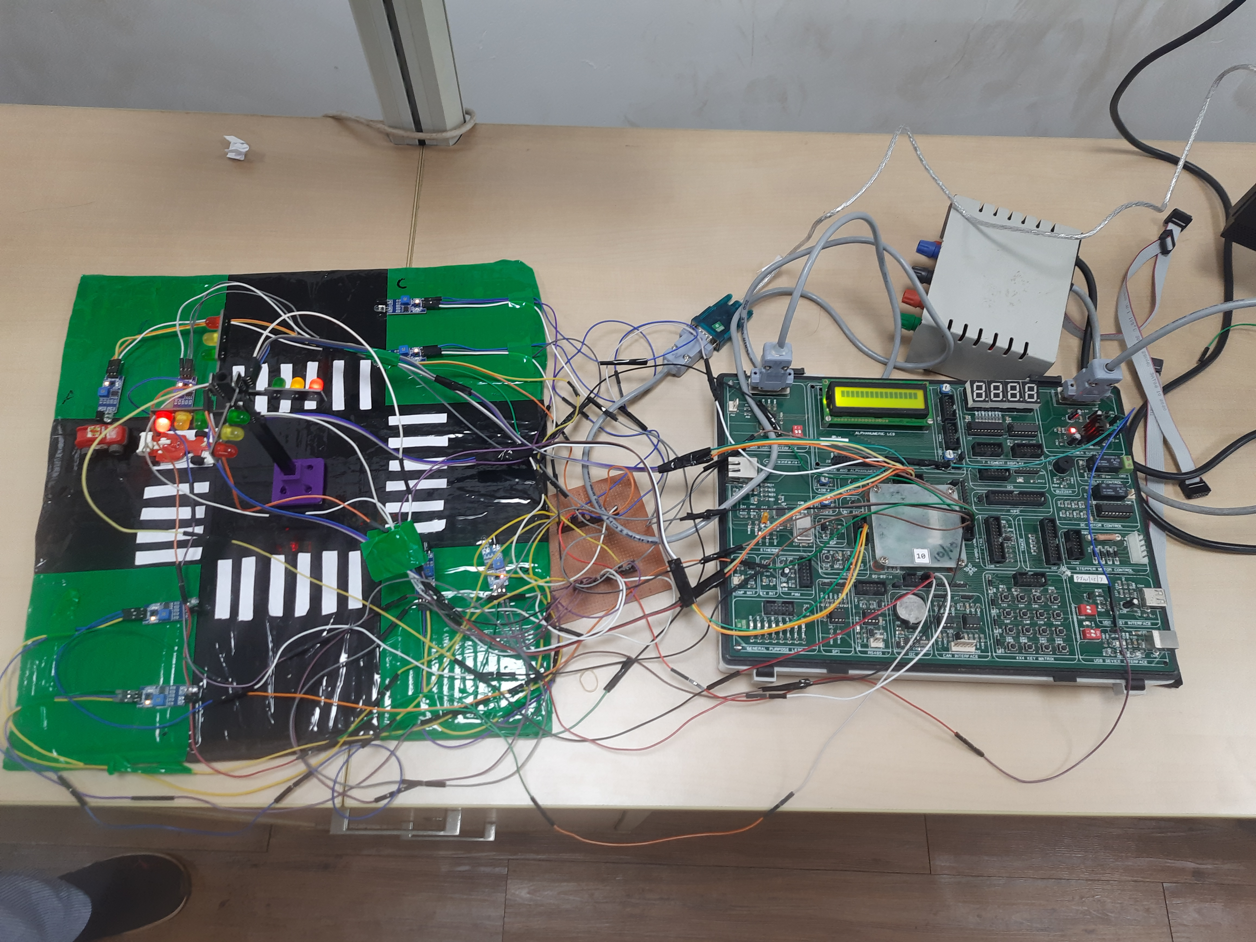

**Application**

1.Urban Traffic Management:Implementing this system at intersections in busy urban areas can significantly improve traffic flow during peak hours. By dynamically adjusting signal timings based on real-time vehicle density, cities can reduce congestion, shorten travel times, and enhance overall transportation efficiency.

2. Smart City Initiatives:Integrating this system into broader smart city initiatives can enhance urban mobility and sustainability. By optimizing traffic flow, cities can reduce carbon emissions from idling vehicles and promote eco-friendly modes of transportation such as cycling and public transit, thus contributing to a greener and more livable urban environment.

3. Emergency Response Optimization: In emergency situations where rapid response times are crucial, such as ambulance or fire truck dispatches, this system can facilitate smoother traffic flow to prioritize the passage of emergency vehicles. By quickly identifying and clearing paths for emergency responders, the system can potentially save lives and mitigate property damage during critical situations.

These applications demonstrate the versatility and potential impact of the density-based traffic light control system in various contexts, from everyday commuting to emergency response scenarios.

**References**

[1].V. Jagadeesh, T. L. Reddy and G. Sundari, ”Traffic Control System for Emergency Vehicles using RFID and Sensors,”2023 7th International Conference on Intelligent Computing and Control Systems (ICICCS), Madurai, India, 2023,pp. 1739-1744, doi: 10.1109/ICICCS56967.2023.10142622.

[2]. S. Amaraneni, A. R. Akula, S. Srikanth,S. R. Vundavalli and A. Gudikandula,”Automated Adaptive IR based Traffic Control,” 2022 7th International Conference on Communication and Electronics Systems (ICCES), Coimbatore, India,2022, pp. 147-151, doi: 10.1109/ICCES54183.2022.9835833.

[3]. Sundar, S. Hebbar and V. Golla, ”Implementing Intelligent Traffic Control System for Congestion Control, Ambulance Clearance, and Stolen Vehicle Detection,”in IEEE Sensors Journal, vol. 15, no. 2,pp. 1109-1113, Feb. 2015,doi:10.1109/JSEN.2014.2360288

